Networking Concepts
DG Interns Hub | Week 1 | TryHackMe Room Writeup

Objective
Review core networking ideas used in cybersecurity.

Activity summary
Completed the guided networking concepts room and questions.

Key learning
Packet flow, addressing and basic network troubleshooting.

Evidence
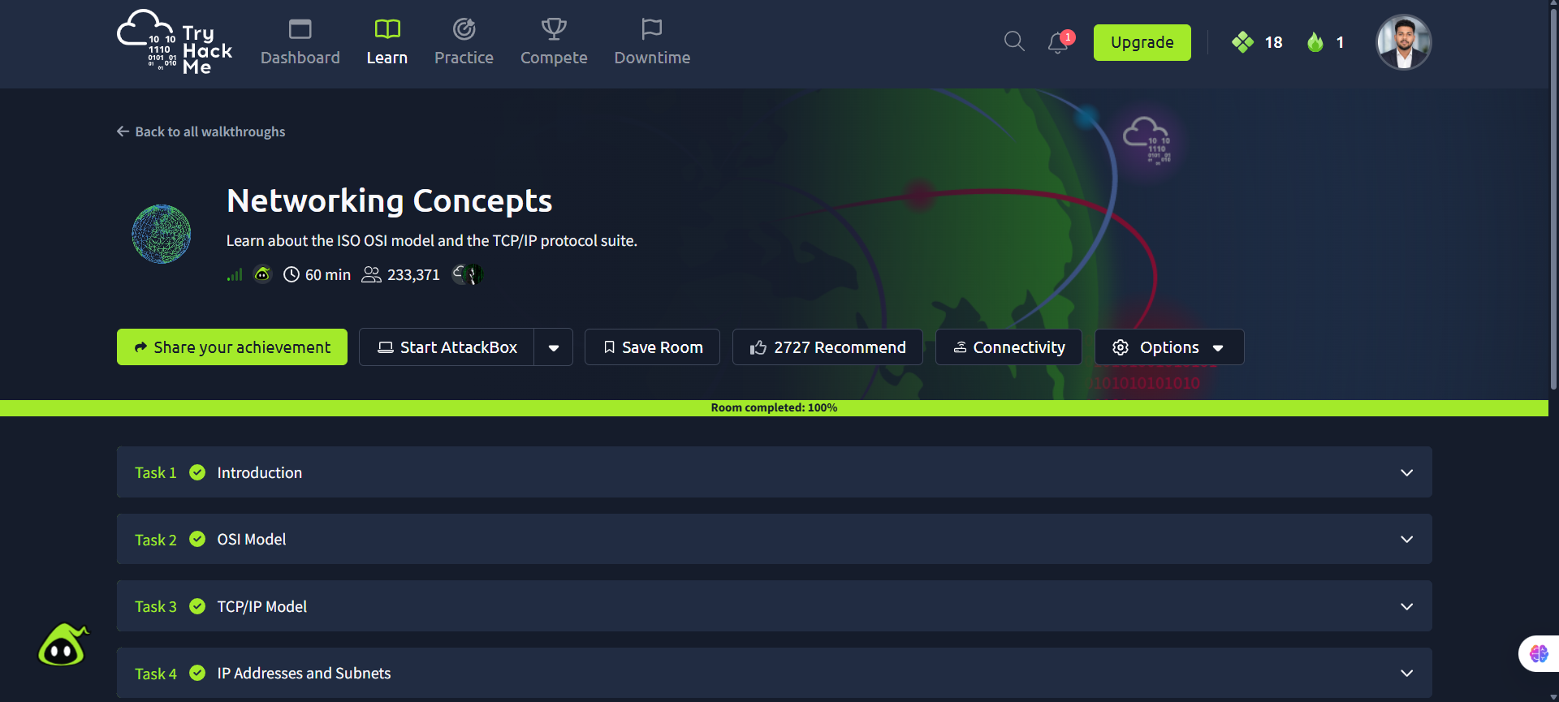
Screenshot: Networking_Concepts.png
Completion screenshot provided; the original step-by-step room answers were not included in the archive.

